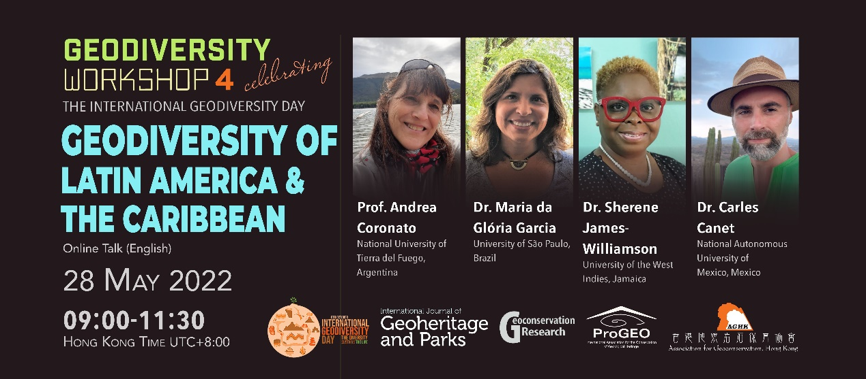
Geodiversity Workshop 4 Celebrating the International Geodiversity Day
Geodiversity of Latin America & the Caribbean
In celebrating the International Geodiversity Day, the Association for Geoconservation, Hong Kong has been organising a series of workshop starting from January until November of 2022. The main themes of the workshops are based on the geodiversity of all continents around the globe except Antarctica. Three workshops had been organised respectively about Asia, Tonga eruption and Europe. The upcoming workshop focuses on the geodiversity of Latin America and the Caribbean which span for approximately 21,951,000 km² from the Bahamas and Mexico to Argentina and Chile. It is a region characterised by extremely varied climate, ecology, culture and geology. Its geodiversity is uniquely stunning and yet little known to many people around the globe. We have therefore invited four key speakers in the region to share their knowledge about the geodiversity of the region.
Details:
Date: Hong Kong 28 May 2022 (Sat)/ Latin America & the Caribbean 27 May (Fri)
Time: Hong Kong Time (UTC+8:00)
08:45 - 09:00 Registration
09:00 - 11:30 Presentations, Q & A

Argentina and Brazil (Sao Paulo): 21:45 (27/5) - 00:30 (28/5)
Mexico City and Jamaica: 19:45 - 22:30 (27/5)

Topics and speakers:
- Geodiversity in Argentina, resources, state of the art and future by Prof. Andrea Coronato, National University of Tierra del Fuego, Argentina
- Geodiversity of Brazil by Dr. Maria da Gloria Garcia, University of São Paulo, Brazil
- Geodiversity of the Caribbean by Dr. Sherene James-Williamson, University of the West Indies, Jamaica
- Mexico, a mega (geo) diverse country: Learned lessons from the Comarca Minera UGGp by Dr. Carles Canet, National Autonomous University of Mexico, Mexico
Language: English
Fee: free
Software: Zoom (Login details will be sent by email later)
Registration:
1. enter google form
https://forms.gle/z72cRmLpuJzVsx4s8
OR
2. email talk@rocks.org.hk to register indicating the following:
- Full Name (same as Identity Document)
- Email Address
- Affiliation
Registration deadline: 22 May 2022
Enquiries: talk@rocks.org.hk

Successful registrants will be notified by email later. In case of any disputes, the decision of AGHK shall be final and conclusive.

Brief biography of speakers
Prof. Andrea Coronato is a full researcher at Austral Centre for Scientific Research-Argentine National Council of Science and Technology and is also a member of the Executive Committee and the co-ordinator of Latin America of the International Association of Geomorphologists (IAG). Besides, she is a member of the Argentinian Association of Quaternary and Geomorphology. Her research interests are on glacial, fluvial, lacustrine and aeolian geomorphology, neotectonics, Quaternary geology, peat bog stratigraphy, geoarchaeology, geodiversity and science diffusion. She published more than 80 papers and 40 book chapters as well as co-authored two books on glaciations and physical geography of Patagonia.
Dr. Maria da Glória Garcia is a geologist specialising in the field of geoconservation and structural Geology. She has been working on topics related to identification, assessment and management of geological sites associated with sustainable public policies and protected areas. She is currently the representative for South America of the Geoheritage Specialist Group of the International Union for Conservation of Nature - World’s Commission on Protected Areas (UCN-WCPA’s) and a member of International Association for the Conservation of Geological Heritage (ProGEO).
Dr. Sherene James-Williamson is a geologist by training and is specially interested in geoheritage, geoarchaeology and geoscience education. She has recently received a UNESCO International Geoscience Programme Grant (IGCP 718) for her project ‘Bringing Geoheritage to Life’. She is one of the Principal Investigators for the UNESCO commissioned survey of the potential for geoparks in Small Island Developing States (SIDS). She is the past president of the Museums Association of the Caribbean and serves as editor of ‘Caribbean Museums’ and the ‘Caribbean Journal of Earth Science’.
Dr. Carles Canet specialises in hydrothermal systems, including ore deposits and geothermal activities. He has published 80 papers on fluid-rock interactions and ore forming processes. He has actively participated in geopark development since 2014 and had successfully helped to set up the Comarca Minera UNESCO Global Geopark in 2017. Dr. Canet is a member of the Scientific Board of the UNESCO’s International Geoscience Programme (IGP).

Association for Geoconservation, Hong Kong

